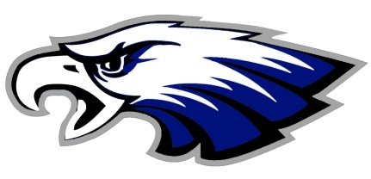
Overton Public School Mark A. Aten, Superintendent
P.O. Box 310, 401 7th St. Brian Fleischman, Principal /
Overton, NE 68863-0310 Activities Director
Calli McCoy, Counselor

Phone (308) 987-2424 Fax (308) 987-2349 www.overtoneagles.org

Good morning,

I have said from day one that change was inevitable throughout this school year given the Pandemic we reside in. Mr. Aten and I have been visiting non-stop during these times to provide guidance for our students and athletes to keep them in the classroom and in their athletic competitions. Monday we received new guidance from our health department that provided confirmation of the practices we have implemented as well as some new guidance. Their guidance has finally addressed extra-curricular activities, specifically outdoor events and events in large gyms.

The guidance referencing extra-curricular activities is as follows:
- If the exposure occurs during extra-curricular activities that take place outdoors or in large spaces (such as gyms) where 6-food distance can be maintained, in lieu of quarantine, close contacts may self-monitor. Students self-monitoring are required to wear masks at all times.
This guidance falls directly in line with what we have already been doing with our sports teams if exposure has occurred.

So what does this mean moving forward for our sports teams? The one change that will occur to our current practice is that while directly involved in competition, masks would not be required by the players while directly in competition. Players on the bench and sidelines will be required to wear a mask. The option to wear a mask doesn’t come without obvious risk. If you are on the court or field, maintaining a 6-foot distance is going to be difficult. According to the new guidance these players would have to quarantine for 10-14 days, per their doctor’s orders, if a positive case developed from one of the players in the game. I will fight for our players to stay on the court or field of battle, but the guidance is clear on players without a mask on.

Please understand that I will fight as hard as I can for all players who are wearing a mask during competition as their guidance all along has stated anyone with a mask on would not have to quarantine. I am holding strong to this guidance and is why we are continuing to require masks during the school day for all students, for all players on the bench or sideline, for our cross country runners while at the start of their races, for all fans at all indoor events, and for our fans who can’t socially distance at football games.

Our #1 goal through all this has been and remains to keep our students in the classroom and competing in their chosen sport and/or activity. Please have a conversation with your child at home about your intentions for them while competing directly in their contests. Students are still encouraged to wear masks at all times but the new guidance does provide families with options. If you have questions, please do not hesitate to contact me at school.

Yours in Education,
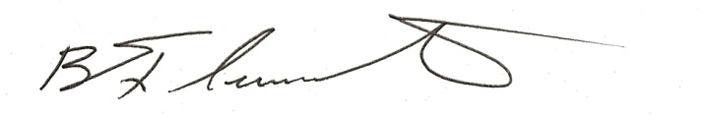
Mr. Brian Fleischman, PK-12 Principal/AD
Overton Public School

